Keeve Lab 11

# Exercise 1

library(rioja)

## This is rioja 0.9-15.1

library(palaeoSig)

## Loading required package: vegan

## Loading required package: permute

## Loading required package: lattice

## This is vegan 2.5-2

library(analogue)

## analogue version 0.17-0

##   
## Attaching package: 'analogue'

## The following objects are masked from 'package:rioja':  
##   
## crossval, performance

data(SWAP)  
data(RLGH)

Test reconstructions using randomTF:

SWAP_sqrt <- sqrt(SWAP$spec)  
RLGH_sqrt <- sqrt(RLGH$spec)  
  
randomTF_wa <- randomTF(spp=SWAP_sqrt,env=SWAP$pH,fos=RLGH_sqrt,fun=WA)  
randomTF_wapls <- randomTF(spp=SWAP$spec,env=SWAP$pH,fos=RLGH$spec,fun=WAPLS)  
randomTF_mat <- randomTF(spp=as.data.frame(SWAP_sqrt),env=data.frame(pH=SWAP$pH),fos=as.data.frame(RLGH_sqrt),fun=MAT,dist.method="euclidean")  
  
plot(randomTF_wa)

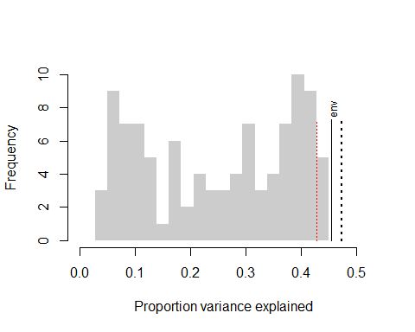

plot(randomTF_wapls) #There's a bug, plotting histogram instead!

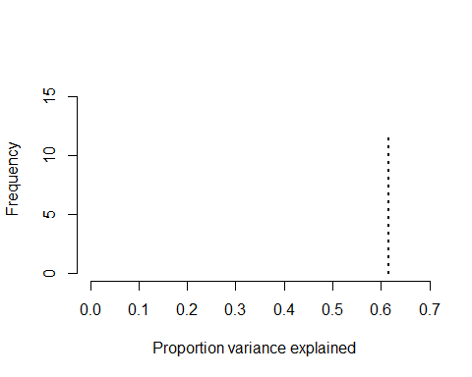

hist(randomTF_wapls$sim.ex)

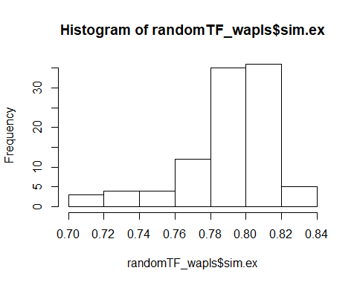

plot(randomTF_mat)

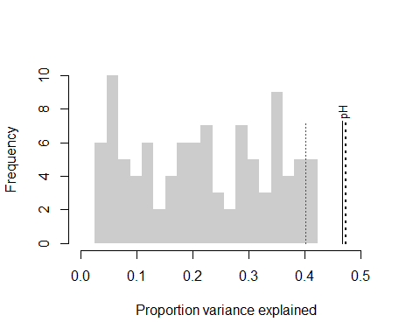 WA and WAPLS tests using obs.cor:

randomTF_wapls

## $PCA  
## Call: rda(X = fos)  
##   
## Inertia Rank  
## Total 70.18   
## Unconstrained 70.18 19  
## Inertia is variance   
##   
## Eigenvalues for unconstrained axes:  
## PC1 PC2 PC3 PC4 PC5 PC6 PC7 PC8   
## 43.27 11.37 3.55 3.03 2.00 1.45 1.06 0.82   
## (Showed only 8 of all 19 unconstrained eigenvalues)  
##   
##   
## $preds  
## $preds$env  
## Comp01 Comp02 Comp03 Comp04 Comp05  
## 00.3 4.882533 4.829229 4.855036 4.883113 4.855677  
## 00.8 4.826818 4.768177 4.785845 4.797670 4.748740  
## 01.3 4.831101 4.764699 4.787472 4.812467 4.772916  
## 01.8 4.797677 4.729999 4.751894 4.782812 4.755881  
## 02.3 4.798345 4.724502 4.739665 4.765811 4.735969  
## 02.8 4.856337 4.801987 4.830993 4.857614 4.821107  
## 03.3 4.797006 4.736764 4.764293 4.791048 4.758850  
## 03.8 4.857158 4.791433 4.796803 4.808551 4.766658  
## 04.3 4.848162 4.794243 4.813022 4.824475 4.778108  
## 04.8 4.878923 4.827394 4.873779 4.929788 4.934607  
## 05.8 4.906327 4.844205 4.848691 4.852796 4.791889  
## 06.8 4.901223 4.853747 4.856597 4.841399 4.763563  
## 07.8 4.921529 4.857765 4.865361 4.882361 4.838566  
## 08.8 4.928193 4.881731 4.904686 4.928137 4.895318  
## 09.8 4.922732 4.860951 4.875570 4.905863 4.879305  
## 11.5 4.925666 4.879152 4.908635 4.936733 4.905652  
## 13.5 4.998118 4.945673 4.960850 4.986530 4.951474  
## 15.5 5.135840 5.132785 5.182271 5.203447 5.154181  
## 17.5 5.303798 5.312734 5.360379 5.373823 5.306297  
## 19.5 5.319236 5.338236 5.387477 5.393243 5.314646  
##   
##   
## $MAX  
## PC1   
## 0.6164848   
##   
## $EX  
## env   
## 0.7605403   
##   
## $eig1  
## env.PC1   
## 0.08986239   
##   
## $sim.ex  
## [1] 0.8181848 0.8008640 0.7829748 0.7174516 0.7063054 0.7953938 0.7890282  
## [8] 0.8045375 0.8175970 0.7752061 0.8267808 0.8026043 0.7918782 0.8061448  
## [15] 0.7815407 0.7167181 0.8136312 0.7552868 0.7618062 0.7795078 0.8061556  
## [22] 0.7725909 0.7960119 0.8188184 0.8008575 0.7930634 0.7859877 0.7330098  
## [29] 0.7660581 0.7972968 0.7985174 0.7886951 0.8086258 0.7980305 0.7679549  
## [36] 0.8013538 0.8021496 0.7779933 0.7911720 0.8173062 0.8182659 0.7847836  
## [43] 0.7857778 0.7608466 0.7957656 0.8096068 0.8125684 0.7219507 0.8386384  
## [50] 0.7863642 0.8120958 0.8155026 0.8038737 0.7999589 0.8071551 0.7420539  
## [57] 0.7723165 0.7943592 0.7942722 0.7909995 0.8131306 0.7810270 0.7905471  
## [64] 0.7549087 0.7741753 0.8230630 0.8172227 0.8126254 0.8145545 0.7958615  
## [71] 0.7815840 0.8063604 0.7897239 0.8091681 0.8089618 0.7988204 0.7343818  
## [78] 0.8017879 0.7890365 0.8057467 0.8017090 0.8176193 0.7887883 0.7649517  
## [85] 0.7926242 0.7446972 0.7344679 0.7616831 0.8283642 0.8091096 0.8316473  
## [92] 0.7899461 0.8014796 0.8197357 0.7979773 0.8120479 0.7933617 0.7935974  
## [99] 0.7903263  
##   
## $sig  
## env   
## 0.89   
##   
## attr(,"class")  
## [1] "palaeoSig"

obs_wa <- obs.cor(spp=SWAP_sqrt,env=SWAP$pH,fos=RLGH_sqrt)  
plot(obs_wa)

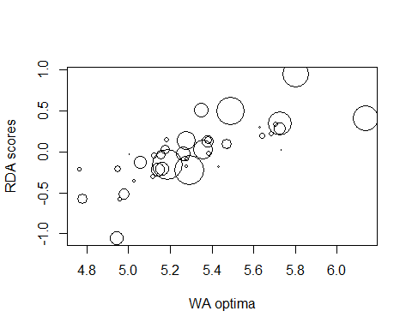

obs_wa

## $ob  
## $ob$x  
## Optima RDA1 abun.fos abun.calib abun.joint n2.fos  
## AC013A 6.137439 0.40369777 0.8333704 1.55955312 1.29968542 15.96038  
## AC022A 5.278691 0.13633878 1.2136764 1.14947055 1.39508532 19.07340  
## AC046A 5.639290 0.19823310 0.5328482 0.38333670 0.20426029 14.61956  
## AU010A 5.278192 -0.08327211 1.1995161 0.25604273 0.30712738 18.68487  
## BR001A 5.800021 0.94940196 1.8499708 1.65274710 3.05753395 17.38969  
## BR003A 4.951027 -0.20940019 0.6771791 0.40619815 0.27506888 17.14129  
## BR006A 5.355388 0.03255368 2.1007946 1.19560072 2.51171158 19.74324  
## CM010A 5.262959 -0.02750207 0.9625172 0.90616915 0.87220338 19.32448  
## CM014A 5.118826 -0.30791713 0.7811869 0.32033350 0.25024032 17.31387  
## CM017A 5.173748 0.03059332 0.9298120 0.57766738 0.53712205 18.47906  
## CM020A 5.735212 0.02107453 0.4330599 0.06929508 0.03000892 10.76266  
## CM048A 5.726524 0.27947500 0.9028952 0.72968279 0.65882712 18.10862  
## EU002B 5.470753 0.08941057 1.0357647 0.61787187 0.63996988 19.19724  
## EU002E 5.627819 0.30506410 0.5105556 0.17018709 0.08688997 13.57880  
## EU009A 5.164125 -0.21016789 0.7317895 0.83883102 0.61384774 18.38777  
## EU011A 5.156698 -0.03367704 1.1079122 0.56658294 0.62772413 19.21129  
## EU014A 4.762474 -0.21533401 0.5613589 0.23822318 0.13372871 15.29900  
## EU015A 5.122404 -0.04482669 0.9619299 0.37097712 0.35685398 19.01485  
## EU047A 5.188978 -0.16123512 3.5530182 1.89525547 6.73387726 19.82019  
## EU048A 5.057574 -0.13317552 2.3585224 0.80630241 1.90168234 19.28652  
## EU051A 5.185366 0.14060895 0.7450107 0.31321808 0.23335081 18.40106  
## EU051B 5.428608 -0.18539336 0.9205291 0.16510872 0.15198738 18.15619  
## EU9961 5.276493 -0.18492881 0.8554440 0.20144565 0.17232548 17.88509  
## EU9965 5.005029 -0.03914138 0.5119883 0.11911587 0.06098594 13.78288  
## FR005D 5.726004 0.33772751 1.3999441 1.47530980 2.06535128 18.76966  
## FU002B 5.289053 -0.22213085 3.0816872 1.82438397 5.62218069 19.80931  
## FU002F 5.380524 0.12647194 1.3180493 0.71336955 0.94025625 19.37635  
## NA006A 5.383220 0.14142536 0.8780457 0.47940499 0.42093951 17.24150  
## NA032A 5.686109 0.22064457 0.6325703 0.30437377 0.19253781 17.19729  
## NA140A 4.956357 -0.58158394 1.3836510 0.24746549 0.34240586 17.37537  
## NA156A 5.144542 -0.21757103 2.4821984 0.86095293 2.13705598 19.80949  
## NA158A 5.026535 -0.35576840 1.0690810 0.21824827 0.23332509 17.96517  
## NA167A 4.976634 -0.51822136 1.6990010 0.70112760 1.19121651 18.53128  
## NE012A 5.479814 0.03939574 0.5183353 0.02812003 0.01457561 14.78713  
## NI005A 5.707571 0.32847402 0.6681537 0.33612277 0.22458166 16.22286  
## PE002A 5.349927 0.51412126 1.9953667 0.90081565 1.79745755 18.95382  
## PI011A 5.386976 -0.02877584 0.5380888 0.30152432 0.16224685 13.85848  
## TA001A 5.489043 0.50048225 1.6288947 1.71173869 2.78824200 18.71635  
## TA003A 4.778656 -0.58083834 1.0127388 0.60895898 0.61671641 15.70191  
## TA004A 4.944152 -1.05789175 3.0782920 0.82930674 2.55284832 18.69623  
## n2.calib n2.joint  
## AC013A 79.328006 1266.10518  
## AC022A 70.218471 1339.30471  
## AC046A 74.662155 1091.52758  
## AU010A 37.512181 700.91019  
## BR001A 100.321107 1744.55309  
## BR003A 41.170256 705.71141  
## BR006A 117.630758 2322.41223  
## CM010A 89.177740 1723.31336  
## CM014A 30.245078 523.65942  
## CM017A 82.872202 1531.40014  
## CM020A 14.603884 157.17657  
## CM048A 93.863052 1699.73078  
## EU002B 104.015848 1996.81703  
## EU002E 41.128674 558.47791  
## EU009A 89.569335 1646.98073  
## EU011A 70.834890 1360.82960  
## EU014A 31.749422 485.73442  
## EU015A 50.048200 951.65900  
## EU047A 111.774860 2215.39841  
## EU048A 86.134426 1661.23329  
## EU051A 60.842030 1119.55806  
## EU051B 31.586162 573.48422  
## EU9961 31.898124 570.50068  
## EU9965 19.042619 262.46219  
## FR005D 76.518671 1436.22978  
## FU002B 120.855004 2394.05440  
## FU002F 71.169411 1379.00362  
## NA006A 92.040567 1586.91782  
## NA032A 60.865291 1046.71833  
## NA140A 30.912202 537.11080  
## NA156A 70.796031 1402.43345  
## NA158A 31.651595 568.62617  
## NA167A 62.020685 1149.32265  
## NE012A 4.922509 72.78978  
## NI005A 55.688545 903.42731  
## PE002A 101.366363 1921.27983  
## PI011A 66.376490 919.87741  
## TA001A 119.697295 2240.29629  
## TA003A 41.261148 647.87893  
## TA004A 54.639502 1021.55253  
##   
## $ob$res  
## abun.fos abun.calib abun.joint n2.fos n2.calib n2.joint   
## 0.7822920 0.7764173 0.8093456 0.7588893 0.7608677 0.7612817   
## unweighted   
## 0.7556077   
##   
##   
## $sim  
## abun.fos abun.calib abun.joint n2.fos n2.calib n2.joint  
## 1 0.1809415 0.29569717 0.248182734 0.2593266 0.2357526 0.2277896  
## 2 0.3940456 0.26047080 0.297907289 0.3644914 0.2588921 0.2717820  
## 3 0.2918752 0.18359944 0.174248155 0.3592643 0.2781092 0.2619381  
## 4 0.4433179 0.28113652 0.192630053 0.5538564 0.4017240 0.3855292  
## 5 0.4066549 0.12075360 0.218643387 0.4686676 0.2601714 0.2505989  
## 6 0.5404989 0.56297111 0.658199924 0.4656603 0.4918890 0.4949948  
## 7 0.4669548 0.44916344 0.570445852 0.3367376 0.3907575 0.3940846  
## 8 0.4964538 0.49922999 0.603591119 0.4067659 0.4373904 0.4516240  
## 9 0.4432400 0.44651631 0.540006942 0.3525732 0.3834844 0.3811560  
## 10 0.4370797 0.52860561 0.511587619 0.4221317 0.4898251 0.4833409  
## 11 0.4154523 0.46603303 0.503504575 0.3683915 0.4165719 0.4039601  
## 12 0.1449262 0.28163427 0.097545506 0.2929185 0.2845943 0.2566265  
## 13 0.3211161 0.30996868 0.276238826 0.3875939 0.3289201 0.3167173  
## 14 0.4392284 0.42635525 0.426258911 0.4655134 0.3968664 0.3913745  
## 15 0.3259192 0.30827655 0.295660444 0.3213202 0.2726713 0.2678470  
## 16 0.3311244 0.42757679 0.402700662 0.3625153 0.4106300 0.4034829  
## 17 0.1576910 0.26569557 0.070494379 0.2848049 0.3181893 0.2968665  
## 18 0.2961129 0.40745575 0.419490574 0.3018801 0.3558705 0.3435741  
## 19 0.3678288 0.47039704 0.511950879 0.3763936 0.4006748 0.4022831  
## 20 0.3371409 0.45191508 0.447945931 0.3845360 0.4366225 0.4337006  
## 21 0.5234715 0.49699753 0.574579020 0.4454502 0.4417032 0.4482121  
## 22 0.2859856 0.30037103 0.226962860 0.3462967 0.2953934 0.2818941  
## 23 0.2910250 0.42591672 0.398929844 0.3178542 0.3394556 0.3304162  
## 24 0.3743223 0.30616152 0.436949641 0.3570027 0.3031692 0.2929533  
## 25 0.4781228 0.58720865 0.677566582 0.4070421 0.4829478 0.4947644  
## 26 0.4439211 0.49160581 0.404626071 0.5013544 0.4853461 0.4666720  
## 27 0.2948153 0.44022530 0.388182096 0.3238213 0.4128684 0.4067877  
## 28 0.3814357 0.45279862 0.380723057 0.4424372 0.4349796 0.4193646  
## 29 0.1649143 0.10739234 0.048297436 0.3372034 0.2273937 0.2028149  
## 30 0.3667775 0.51691675 0.397353787 0.5051144 0.5154446 0.5010993  
## 31 0.3446924 0.39976960 0.370394782 0.3929123 0.3819994 0.3684477  
## 32 0.4438279 0.52349313 0.489812853 0.4528019 0.4706668 0.4597092  
## 33 0.5222960 0.54053957 0.598429309 0.4687003 0.4866333 0.4916013  
## 34 0.3590409 0.33742242 0.409618289 0.2797171 0.2893135 0.2996859  
## 35 0.2633878 0.33267714 0.203395211 0.3878991 0.3245641 0.3055563  
## 36 0.1641644 0.21793784 0.109530085 0.2946798 0.2457435 0.2286452  
## 37 0.3069365 0.25830652 0.313078998 0.3928869 0.2156530 0.1972754  
## 38 0.4186486 0.35959993 0.309060256 0.5162066 0.3587673 0.3400864  
## 39 0.6398909 0.76884177 0.829617960 0.5266075 0.6840950 0.6954115  
## 40 0.3203526 0.34559510 0.341766049 0.3785864 0.3751316 0.3597037  
## 41 0.3879953 0.42861848 0.430107444 0.4017636 0.4086263 0.4021999  
## 42 0.2891451 0.33997311 0.330414455 0.3554711 0.3295515 0.3110352  
## 43 0.4269826 0.32985328 0.444145452 0.3659182 0.3247111 0.3283056  
## 44 0.1281844 0.10239792 0.059006321 0.3150406 0.2457756 0.2313316  
## 45 0.2142086 0.21312315 0.201402657 0.2831184 0.2070865 0.1956484  
## 46 0.3530244 0.25445227 0.373386960 0.3472063 0.2747600 0.2790828  
## 47 0.3321618 0.24294266 0.271100563 0.3091852 0.2870246 0.2835019  
## 48 0.3410307 0.11507418 0.076473325 0.5234592 0.2438069 0.1944695  
## 49 0.4077910 0.51557695 0.532215363 0.4050144 0.4600980 0.4620900  
## 50 0.4211431 0.53659037 0.505013896 0.4511780 0.4936093 0.4829644  
## 51 0.3136913 0.36990115 0.332969324 0.3519828 0.3804597 0.3684124  
## 52 0.3401665 0.14216425 0.170727039 0.4183322 0.2310182 0.2341426  
## 53 0.4523986 0.50492869 0.479241393 0.4592632 0.4480887 0.4371793  
## 54 0.3803145 0.42800935 0.227094695 0.5119205 0.4817966 0.4429530  
## 55 0.5941586 0.68539255 0.769411044 0.5272688 0.6176266 0.6252588  
## 56 0.1323649 0.27645570 0.150026236 0.2754517 0.2953305 0.2862642  
## 57 0.3474851 0.45112412 0.472985458 0.3627970 0.4212800 0.4016595  
## 58 0.2534876 0.19428140 0.124994696 0.3967282 0.2717176 0.2591749  
## 59 0.2367291 0.30059682 0.198682219 0.3452564 0.2979050 0.2732229  
## 60 0.4391034 0.44875216 0.447182402 0.3965212 0.3915545 0.3896805  
## 61 0.4555569 0.50780242 0.485574518 0.4758982 0.4993562 0.4855349  
## 62 0.4137646 0.45837037 0.607058930 0.2755763 0.3624639 0.3627131  
## 63 0.4494580 0.48934408 0.377737200 0.5751738 0.4988447 0.4811918  
## 64 0.3640762 0.36856181 0.379972947 0.3881343 0.3572466 0.3516575  
## 65 0.4266356 0.24125824 0.127585952 0.5865101 0.3043219 0.2927681  
## 66 0.4925619 0.47062938 0.533172546 0.4200776 0.4241070 0.4117579  
## 67 0.3728706 0.22181297 0.100204246 0.4703569 0.3226626 0.3228961  
## 68 0.2574184 0.40657011 0.343904738 0.2919034 0.3547028 0.3419593  
## 69 0.2331875 0.32195522 0.142137703 0.4078505 0.3526205 0.3339544  
## 70 0.5684786 0.61944223 0.709517993 0.4894864 0.5583807 0.5555329  
## 71 0.4225468 0.43273675 0.485501644 0.3791260 0.3692718 0.3673618  
## 72 0.4871487 0.46217589 0.514885084 0.5184318 0.4691851 0.4576130  
## 73 0.4114568 0.38665127 0.365138502 0.4619429 0.3914974 0.3691825  
## 74 0.2271482 0.33292592 0.140600013 0.3871524 0.3280980 0.3029384  
## 75 0.3475330 0.27263125 0.327584352 0.3142239 0.2804015 0.2740868  
## 76 0.2517519 0.29714195 0.272093925 0.2663438 0.2651010 0.2551217  
## 77 0.2196035 0.28548092 0.117824005 0.3442298 0.3045208 0.2828021  
## 78 0.1086690 0.12664357 0.001812535 0.2623405 0.1902277 0.1632525  
## 79 0.3135844 0.35977023 0.221901214 0.4181312 0.3740119 0.3689483  
## 80 0.7703880 0.80261955 0.830698046 0.7392064 0.7715820 0.7734548  
## 81 0.2173205 0.22696156 0.092808907 0.3473777 0.2485648 0.2158890  
## 82 0.3989428 0.33540696 0.361481096 0.3881710 0.3277562 0.3122282  
## 83 0.5719612 0.55189609 0.679844917 0.4641370 0.5033357 0.5148672  
## 84 0.6381502 0.70837793 0.723427406 0.6416693 0.6650162 0.6597082  
## 85 0.3073101 0.38688448 0.465466521 0.3898529 0.3099482 0.2884222  
## 86 0.4531330 0.50829299 0.507571590 0.4578600 0.4690778 0.4673537  
## 87 0.2621257 0.30182720 0.278612586 0.2847353 0.3018293 0.2976064  
## 88 0.4323522 0.29144721 0.391066657 0.4415273 0.3253402 0.3235896  
## 89 0.2916870 0.26606118 0.131493955 0.4629643 0.3349717 0.3063838  
## 90 0.4357639 0.46270450 0.490098209 0.4125471 0.4375657 0.4387906  
## 91 0.4005445 0.47873150 0.467042454 0.4343983 0.4532557 0.4499284  
## 92 0.3260942 0.44977582 0.428216304 0.3734301 0.4011944 0.3968002  
## 93 0.2832771 0.47890428 0.415396990 0.3315465 0.4197145 0.4058114  
## 94 0.3317585 0.46228785 0.462407831 0.3472491 0.4220488 0.4156596  
## 95 0.3029862 0.36978193 0.414919917 0.3168601 0.3674377 0.3703075  
## 96 0.4020109 0.45548035 0.417907099 0.4498500 0.4500496 0.4378756  
## 97 0.3751389 0.40016137 0.221499305 0.5139854 0.4662443 0.4489646  
## 98 0.3393765 0.38249912 0.477497430 0.2907413 0.2727962 0.2725606  
## 99 0.2489402 0.07330941 0.023293346 0.3961767 0.1545144 0.1431541  
## unweighted  
## 1 0.2774515  
## 2 0.3538831  
## 3 0.3924130  
## 4 0.5802069  
## 5 0.5040726  
## 6 0.4657166  
## 7 0.3395562  
## 8 0.3961729  
## 9 0.3623710  
## 10 0.4274365  
## 11 0.3821929  
## 12 0.3534691  
## 13 0.4069632  
## 14 0.4683696  
## 15 0.3278985  
## 16 0.3748368  
## 17 0.3024704  
## 18 0.3207964  
## 19 0.3794573  
## 20 0.3900837  
## 21 0.4342023  
## 22 0.3572336  
## 23 0.3279770  
## 24 0.3877600  
## 25 0.3915768  
## 26 0.5212623  
## 27 0.3316812  
## 28 0.4452795  
## 29 0.3749645  
## 30 0.5183913  
## 31 0.4040279  
## 32 0.4628781  
## 33 0.4591198  
## 34 0.2658407  
## 35 0.4144652  
## 36 0.3224651  
## 37 0.4507813  
## 38 0.5651345  
## 39 0.5139736  
## 40 0.3989560  
## 41 0.4065090  
## 42 0.3908947  
## 43 0.3746293  
## 44 0.3471280  
## 45 0.3046899  
## 46 0.3601692  
## 47 0.3120033  
## 48 0.5760579  
## 49 0.4077101  
## 50 0.4619563  
## 51 0.3645734  
## 52 0.4294043  
## 53 0.4663610  
## 54 0.5661973  
## 55 0.5221180  
## 56 0.2890262  
## 57 0.3889829  
## 58 0.4183805  
## 59 0.3933306  
## 60 0.3973631  
## 61 0.4869483  
## 62 0.2806920  
## 63 0.6140204  
## 64 0.4018558  
## 65 0.6115755  
## 66 0.4292997  
## 67 0.4757503  
## 68 0.3129430  
## 69 0.4326988  
## 70 0.4917672  
## 71 0.3795042  
## 72 0.5492371  
## 73 0.5158032  
## 74 0.4224002  
## 75 0.3257063  
## 76 0.2691163  
## 77 0.3586980  
## 78 0.2896158  
## 79 0.4215326  
## 80 0.7350452  
## 81 0.3959437  
## 82 0.4213124  
## 83 0.4547034  
## 84 0.6414477  
## 85 0.4272686  
## 86 0.4520458  
## 87 0.2978823  
## 88 0.4677950  
## 89 0.5085447  
## 90 0.4140080  
## 91 0.4433712  
## 92 0.3844512  
## 93 0.3406550  
## 94 0.3638297  
## 95 0.3179189  
## 96 0.4608493  
## 97 0.5409375  
## 98 0.2947513  
## 99 0.4292977  
##   
## $sigs  
## abun.fos abun.calib abun.joint n2.fos n2.calib n2.joint   
## 0.01 0.02 0.03 0.01 0.02 0.02   
## unweighted   
## 0.01   
##   
## attr(,"class")  
## [1] "obscor"

# Exercise 4

## Model A

Model_A <- function(x) 1/4  
A_Roll <- Model_A(1:4)  
A_Roll

## [1] 0.25

plot(A_Roll)

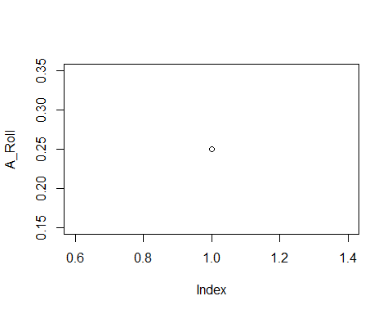

Model A assumes a complete lack of bias towards any result.

## Model B

Model_B <- function(x) x/10  
B_Roll <- Model_B(1:4)  
B_Roll

## [1] 0.1 0.2 0.3 0.4

plot(B_Roll)

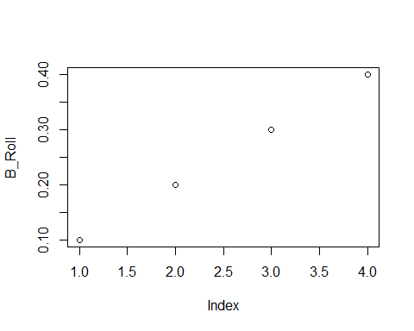

Model B has a linearly increasing bias towards higher rolls

## Model C

Model_C <- function(x) 12/(25*x)  
C_Roll <- Model_C(1:4)  
C_Roll

## [1] 0.48 0.24 0.16 0.12

plot(C_Roll)

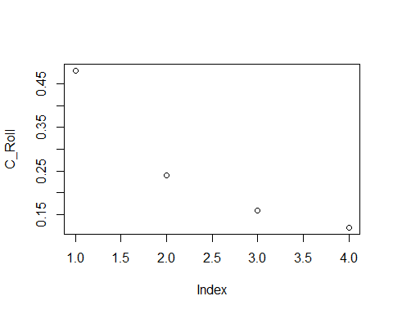

Model C has an asymptotically decreasing bias against higher rolls

# Exercise 5

If p(1)=p(2)=p(3)=p(4)=0.25 after 100 rolls, then this would support Model A, and our beliefs should lean towards an unbiased set of results in the die rolls.

The second scenario would lead us to believe that there is a bias against higher rolls, which would support Model C as most likely.